|  |  |
| --- | --- |
| NAME=Ayushman Pranav  Course- BTech | Type- Core |
| Course Code: CSET 105 | Course Name- Digital Logic Design Lab |
| Year- 2022 | Semester- Even |
| Date- 3/april/2022 | Batch- EB10 |

**Lab Assignment # No. (2.2)**

In this Lab, we shall start Verilog. To run Verilog, we shall use <http://www.edaplayground.com>. After opening you will find Design or Testbench window pane. In the Design window you need write the Verilog Code and in the Testbench window, the testbench verification code will be written.

1. Write a Verilog code to implement AND gate. Write the corresponding Testbench code for the verification of your Verilog code.

Truth Table of AND Gate:

|  |  |  |
| --- | --- | --- |
| A | B | Y |
| 1 | 1 | 1 |
| 1 | 0 | 0 |
| 0 | 1 | 0 |
| 0 | 0 | 0 |

ANS.

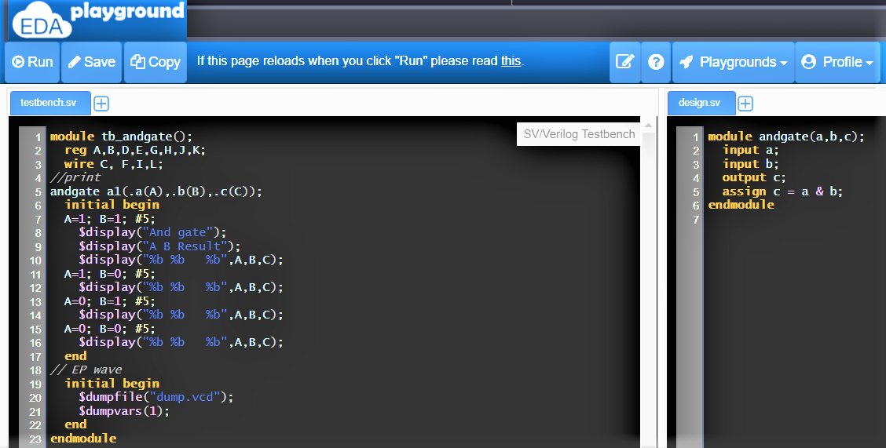

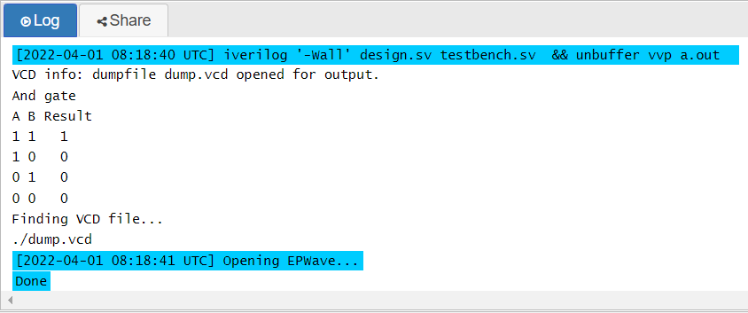

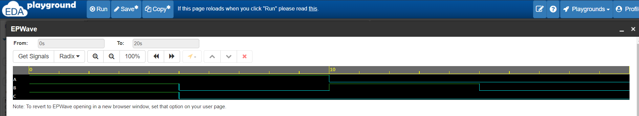

AND GATE (Design Bench.sv)

module andgate(a,b,c);

input a;

input b;

output c;

assign c = a & b;

endmodule

AND GATE (Test Bench.sv)

**module tb_andgate();**

**reg A,B,D,E,G,H,J,K;**

**wire C, F,I,L;**

**//print**

**//Ayushman Pranav E21cseu0245**

**andgate a1(.a(A),.b(B),.c(C));**

**initial begin**

**A=1; B=1; #5;**

**$display("And gate");**

**$display("A B Result");**

**$display("%b %b %b",A,B,C);**

**A=1; B=0; #5;**

**$display("%b %b %b",A,B,C);**

**A=0; B=1; #5;**

**$display("%b %b %b",A,B,C);**

**A=0; B=0; #5;**

**$display("%b %b %b",A,B,C);**

**end**

**// EP wave**

**initial begin**

**$dumpfile("dump.vcd");**

**$dumpvars(1);**

**end**

**endmodule**

**2)**Write a Verilog code to implement OR gate. Write the corresponding Testbench code for the verification of your Verilog code.

Truth Table of OR Gate:

|  |  |  |
| --- | --- | --- |
| A | B | Y |
| 1 | 1 | 1 |
| 1 | 0 | 1 |
| 0 | 1 | 1 |
| 0 | 0 | 0 |

ANS.

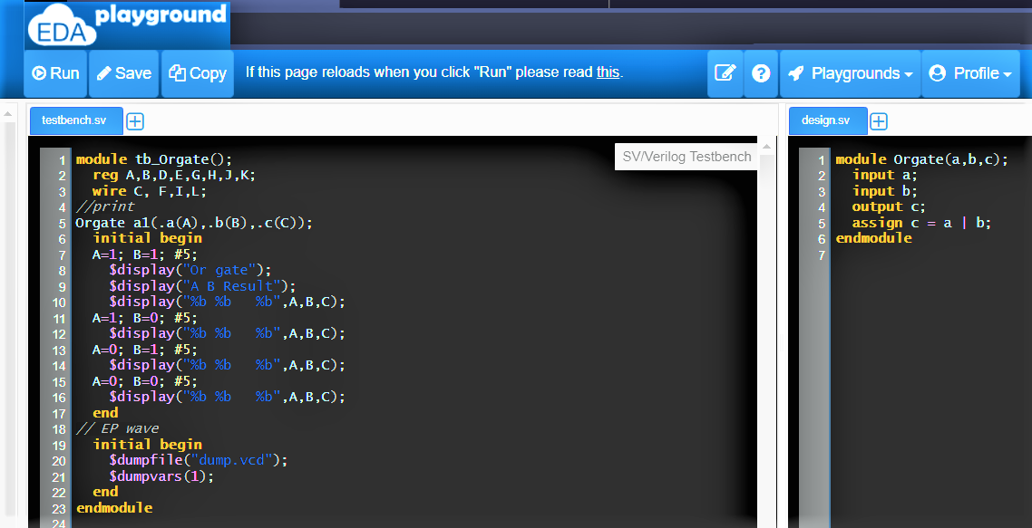

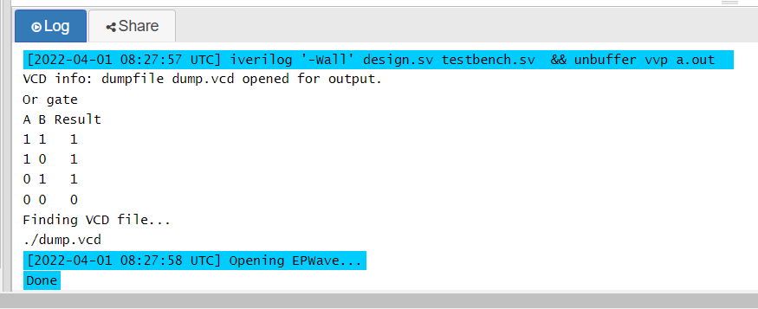

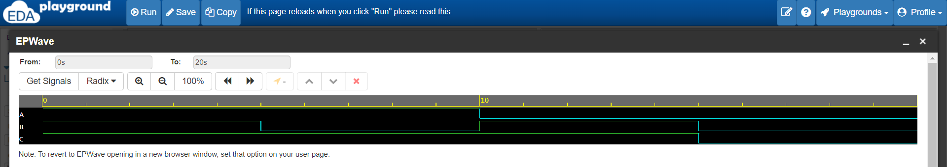

OR GATE (Design bench.sv)

module Orgate(a,b,c);

input a;

input b;

output c;

assign c = a | b;

endmodule

OR GATE (Test bench.sv)

module tb_Orgate();

reg A,B;

wire C;

//print

**//Ayushman Pranav E21cseu0245**

Orgate a1(.a(A),.b(B),.c(C));

initial begin

A=1; B=1; #5;

$display("Or gate");

$display("A B Result");

$display("%b %b %b",A,B,C);

A=1; B=0; #5;

$display("%b %b %b",A,B,C);

A=0; B=1; #5;

$display("%b %b %b",A,B,C);

A=0; B=0; #5;

$display("%b %b %b",A,B,C);

end

// EP wave

initial begin

$dumpfile("dump.vcd");

$dumpvars(1);

end

endmodule

3)Write a Verilog code to implement XOR gate. Write the corresponding Testbench code for the verification of your Verilog code.

Truth Table of XOR Gate:

|  |  |  |
| --- | --- | --- |
| A | B | Y |
| 1 | 1 | 0 |
| 1 | 0 | 1 |
| 0 | 1 | 1 |
| 0 | 0 | 0 |

ANS.

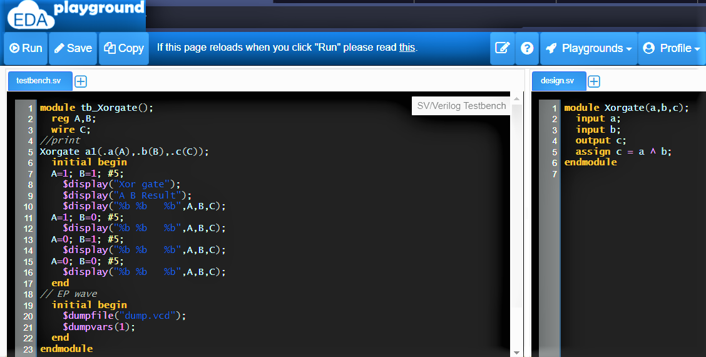

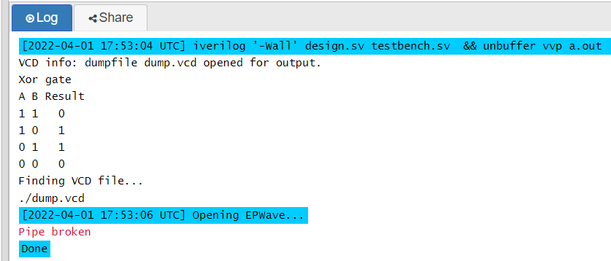

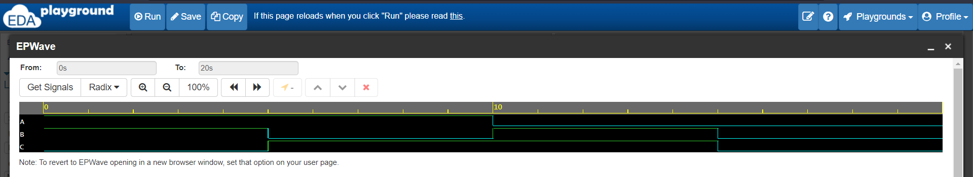

XOR GATE (Design bench.sv)

module Xorgate(a,b,c);

input a;

input b;

output c;

assign c = a ^ b;

endmodule

XOR GATE (Test bench.sv)

module tb_Xorgate();

reg A,B;

wire C;

//print

**//Ayushman Pranav E21cseu0245**

Xorgate a1(.a(A),.b(B),.c(C));

initial begin

A=1; B=1; #5;

$display("Or gate");

$display("A B Result");

$display("%b %b %b",A,B,C);

A=1; B=0; #5;

$display("%b %b %b",A,B,C);

A=0; B=1; #5;

$display("%b %b %b",A,B,C);

A=0; B=0; #5;

$display("%b %b %b",A,B,C);

end

// EP wave

initial begin

$dumpfile("dump.vcd");

$dumpvars(1);

end

endmodule

4) Write a Verilog code to implement NOR gate. Write the corresponding Testbench code for the verification of your Verilog code.

Truth Table of NOR Gate:

|  |  |  |
| --- | --- | --- |
| A | B | Y |
| 1 | 1 | 0 |
| 1 | 0 | 0 |
| 0 | 1 | 0 |
| 0 | 0 | 1 |

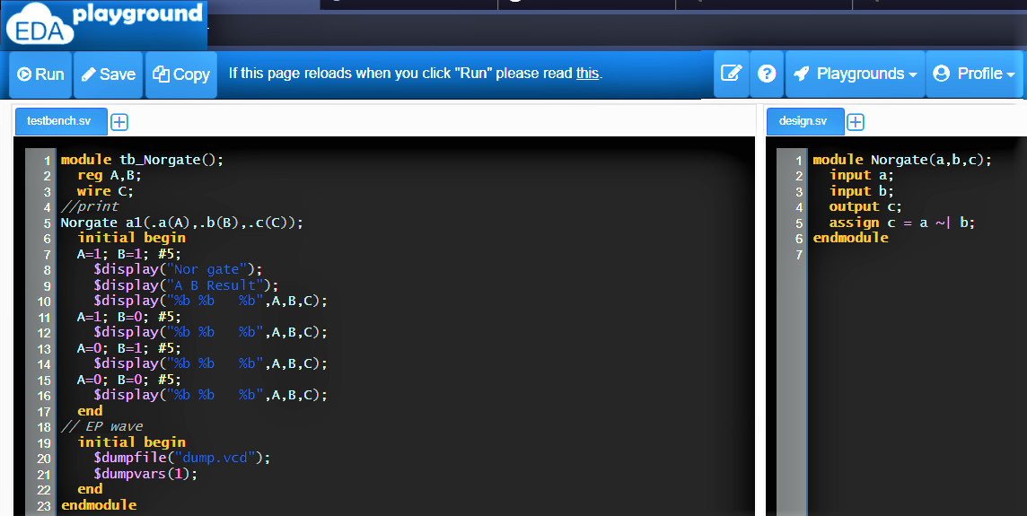

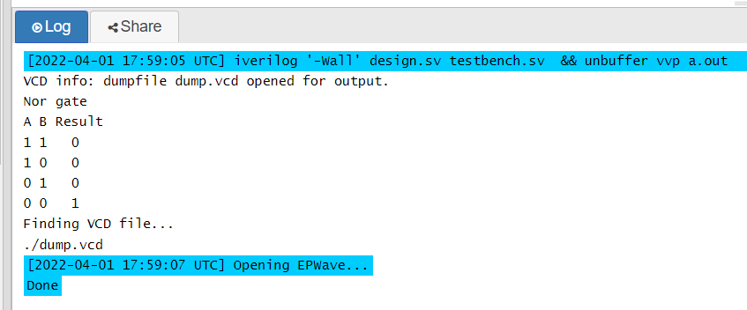

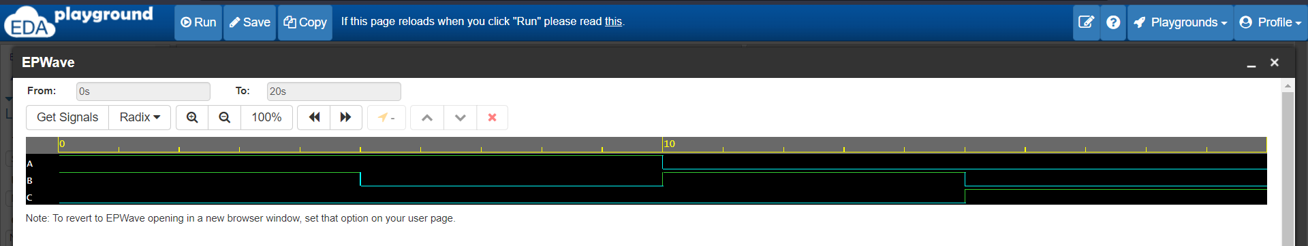

**Nor Gate( Design bench )**

module Norgate(a,b,c);

input a;

input b;

output c;

assign c = a ~| b;

endmodule

**Nor Gate( Test Bench )**

module tb_Norgate();

reg A,B;

wire C;

//print

**//Ayushman Pranav E21cseu0245**

Norgate a1(.a(A),.b(B),.c(C));

initial begin

A=1; B=1; #5;

$display("Nor gate");

$display("A B Result");

$display("%b %b %b",A,B,C);

A=1; B=0; #5;

$display("%b %b %b",A,B,C);

A=0; B=1; #5;

$display("%b %b %b",A,B,C);

A=0; B=0; #5;

$display("%b %b %b",A,B,C);

end

// EP wave

initial begin

$dumpfile("dump.vcd");

$dumpvars(1);

end

endmodule

1. Write a Verilog code to implement NAND gate. Write the corresponding Testbench code for the verification of your Verilog code.

Truth Table of NAND Gate:

|  |  |  |
| --- | --- | --- |
| A | B | Y |
| 1 | 1 | 0 |
| 1 | 0 | 1 |
| 0 | 1 | 1 |
| 0 | 0 | 1 |

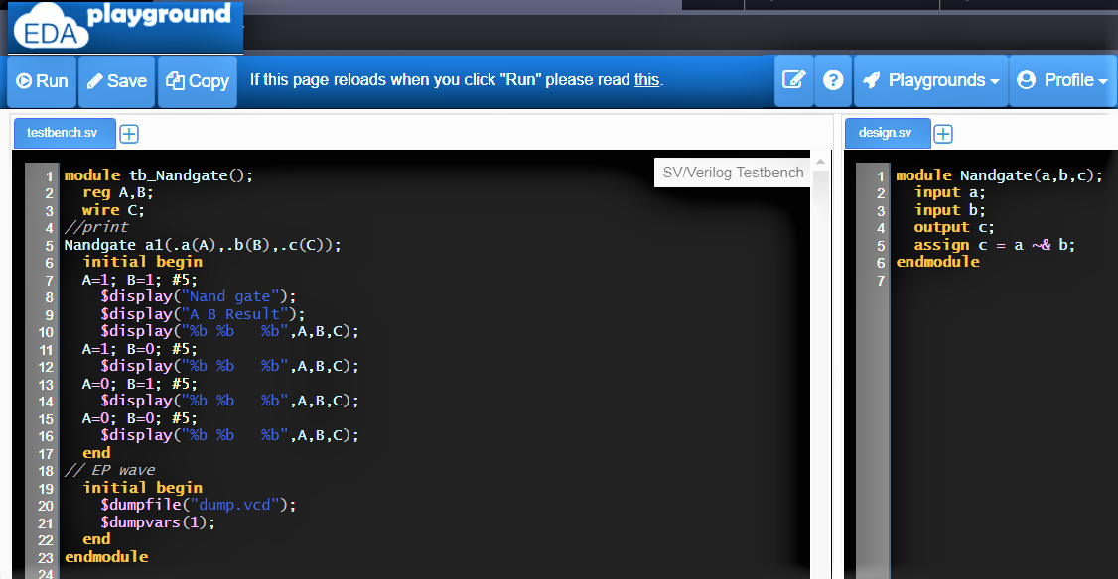

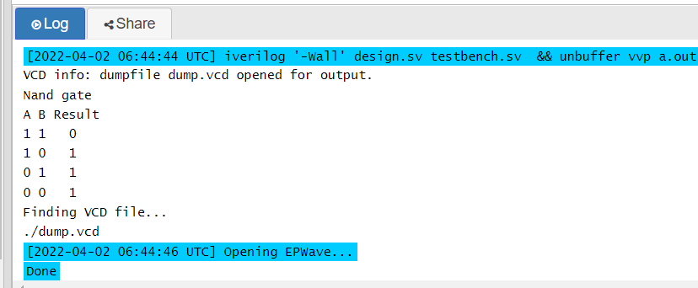

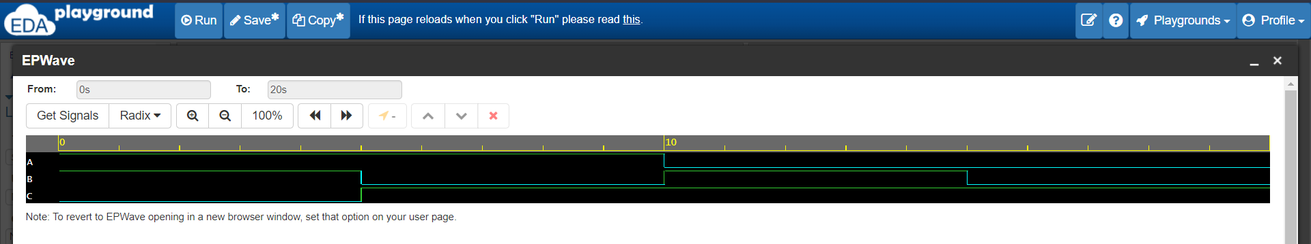

**Nand Gate (Design Bench)**

module Norgate(a,b,c);

input a;

input b;

output c;

assign c = a ~| b;

endmodule

**Nand Gate (Test bench )**

module tb_Norgate();

reg A,B;

wire C;

//print

**//Ayushman Pranav E21cseu0245**

Norgate a1(.a(A),.b(B),.c(C));

initial begin

A=1; B=1; #5;

$display("Nor gate");

$display("A B Result");

$display("%b %b %b",A,B,C);

A=1; B=0; #5;

$display("%b %b %b",A,B,C);

A=0; B=1; #5;

$display("%b %b %b",A,B,C);

A=0; B=0; #5;

$display("%b %b %b",A,B,C);

end

// EP wave

initial begin

$dumpfile("dump.vcd");

$dumpvars(1);

end

endmodule

1. Write a Verilog code to implement XNOR gate. Write the corresponding Testbench code for the verification of your Verilog code.

Truth Table of XNOR Gate:

|  |  |  |
| --- | --- | --- |
| A | B | Y |
| 1 | 1 | 1 |
| 1 | 0 | 0 |
| 0 | 1 | 0 |
| 0 | 0 | 1 |

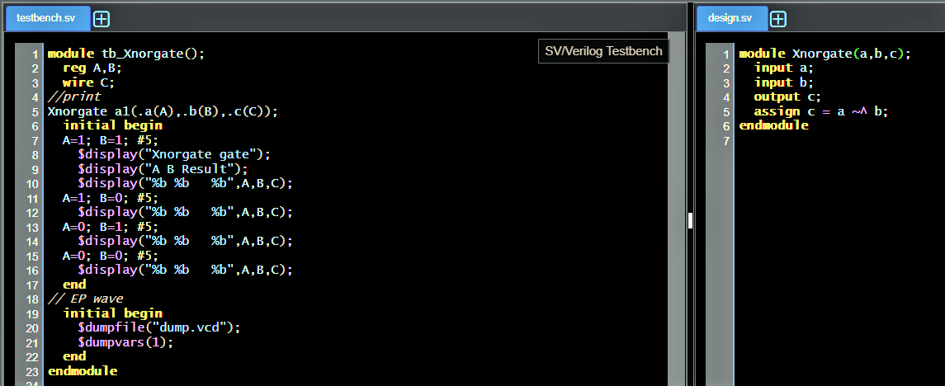

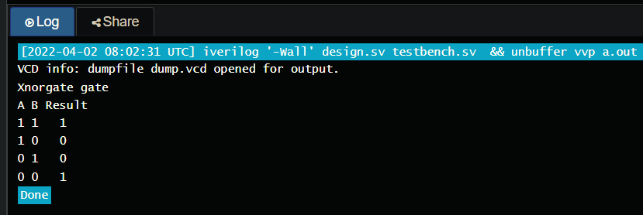

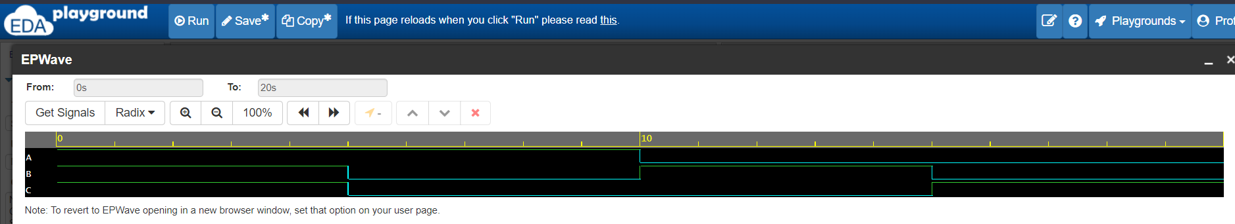

**XnorGate ( Design Bench)**

module Xnorgate(a,b,c);

input a;

input b;

output c;

assign c = a ~^ b;

endmodule

**XnorGate ( Test Bench)**

module tb_Xnorgate();

reg A,B;

wire C;

//print

**//Ayushman Pranav E21cseu0245**

Xnorgate a1(.a(A),.b(B),.c(C));

initial begin

A=1; B=1; #5;

$display("Xnorgate gate");

$display("A B Result");

$display("%b %b %b",A,B,C);

A=1; B=0; #5;

$display("%b %b %b",A,B,C);

A=0; B=1; #5;

$display("%b %b %b",A,B,C);

A=0; B=0; #5;

$display("%b %b %b",A,B,C);

end

// EP wave

initial begin

$dumpfile("dump.vcd");

$dumpvars(1);

end

endmodule